Database Connectivity

Database Driver & Connection

Following table lists down the popular JDBC driver names and database URL.
RDBMS | JDBC driver name | URL format
MySQL | com.mysql.jdbc.Driver | jdbc:mysql://hostname/ databaseName
ORACLE | oracle.jdbc.driver.OracleDriver | jdbc:oracle:thin:@hostname:port Number:databaseName
DB2 | COM.ibm.db2.jdbc.net.DB2Driver | jdbc:db2:hostname:port Number/databaseName
Sybase | com.sybase.jdbc.SybDriver | jdbc:sybase:Tds:hostname: port Number/databaseName

1.1. Connect MYSQL

To connect a Java application with MySQL database using Thin Driver. You need to follow the following steps
- Load Driver Class: The Driver Class for MySQL database is com.mysql.jdbc.Driver and
Class.forName("com.mysql.jdbc.Driver") method is used to load the driver class for MySQL database.
- Create Connection: For creating a connection you will need a Connection URL. The Connection URL for MySQL is:-
Connection con = DriverManager.getConnection("jdbc:mysql://localhost:3306/test","username","password");
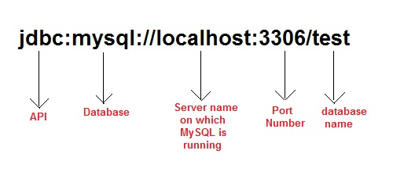
* load Driver only using for sdk 7 and under.
* con is name of the object for Connection.

Activity 1.1

- Create a table in MYSQL Database
create table Student(sid int(10),name varchar(20));

- Insert record into the table
insert into Student values(102,'adam');
insert into Student values(103,'abhi');

- Open Eclipse Java EE IDE. Create new Project name “DB Connectivity”. Create class file name DbCon.java

- Write the code for open a connection to the database
import java.sql.*;
class DbCon {
public static void main(String []args)
{ try{
//Loading driver
Class.forName("com.mysql.jdbc.Driver");

//creating connection
Connection con = DriverManager.getConnection
("jdbc:mysql://localhost:3306/test","username","password");

System.out.println("Connection Success");
}
}catch(Exception e){
System.err.println(e);
}
}
}

1.2. Setting up MYSQL

- Firstly download mysql-connector.jar file, then loading jar file to connect java application with MYSQL.
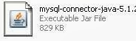

Step 1: -
- Right click on Project, and then pick Folder. Create folder name “external_lib” or any suitable name.

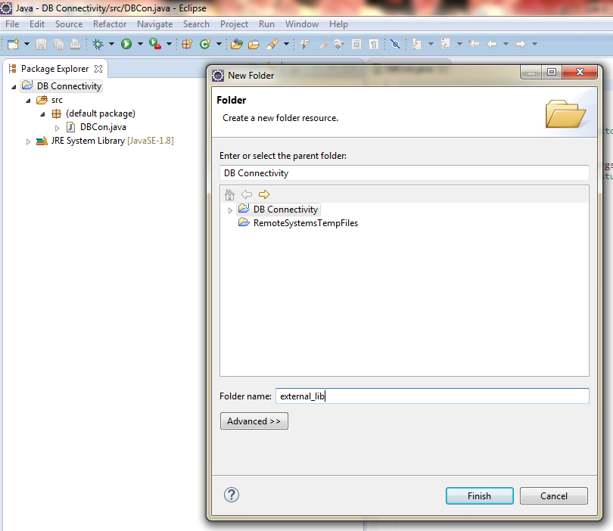

- Paste driver mysql-connector in to the folder “external_lib”.
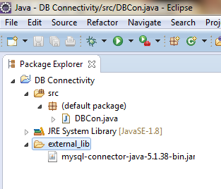

- Right click on Project, select Build Path then click at Configure Build Path.
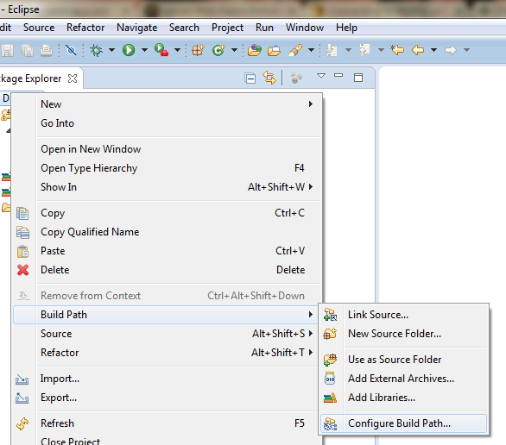

- At the Configure Build Path windows, click tab Libraries and click button Add External JARs..

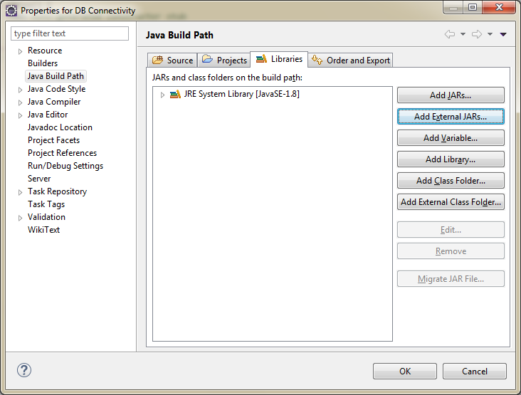

- After click button Add External JARs, choose mysql-connector. After clicked OK, you will see Referenced Libraries will show in Project list.
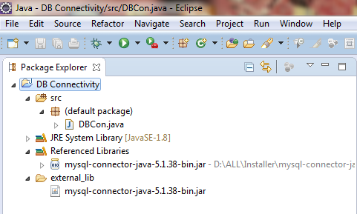

Activity 1.2

- Continue from Activity 1.1

- Insert the following code in try/catch block.

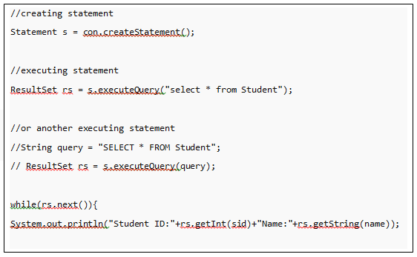

- Run the code and you can see all the information from database.

Activity 1.3

- Create database name perpustakaanDB. Create table named buku.

Filed | Data type
id_buku (PK) | int | Auto_increment
judul | Varchar(50)
pengarang | Varchar(100)

Insert a few data for testing.

- Create class LibraryJDBC

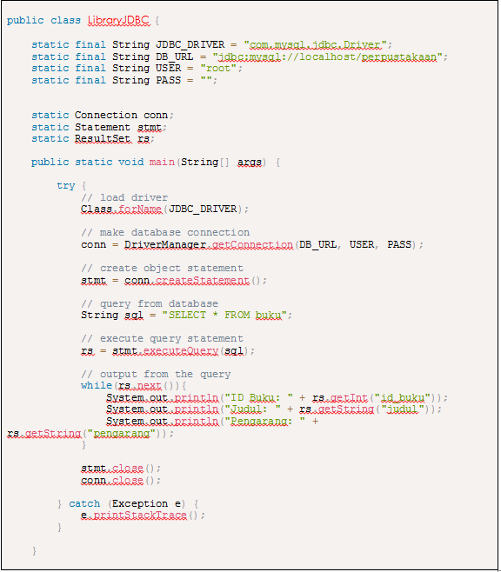

Activity 1.4: CRUD Operation

- Insert new data

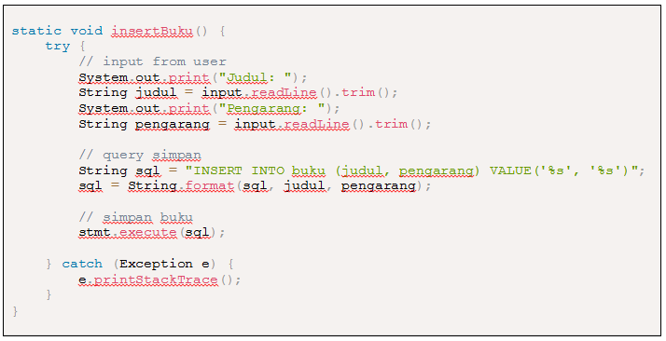

- Update data

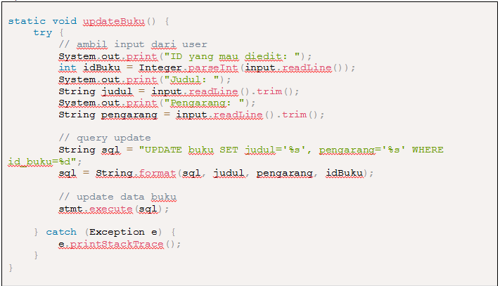

- Delete data

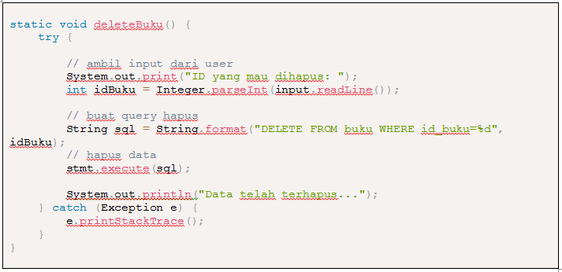

- Full code

